NAME: NAVODITAA A.R
ROLL NO: 241901071

7. SECURE NETWORK ARCHITECTURE
DATE: 11/03/2026
Aim:To learn about and implement security best practices for network environments.
Procedure:
- Log into TryHackMe and open the Secure Network Architecture room.
- Study the fundamentals of secure network design and architecture.
- Understand concepts like network segmentation and zoning.
- Learn the role of security devices such as firewalls and IDS/IPS.
- Explore best practices for protecting network infrastructure.
- Complete the tasks and answer the questions in the room.
- Review the summary and confirm completion.
Tasks:
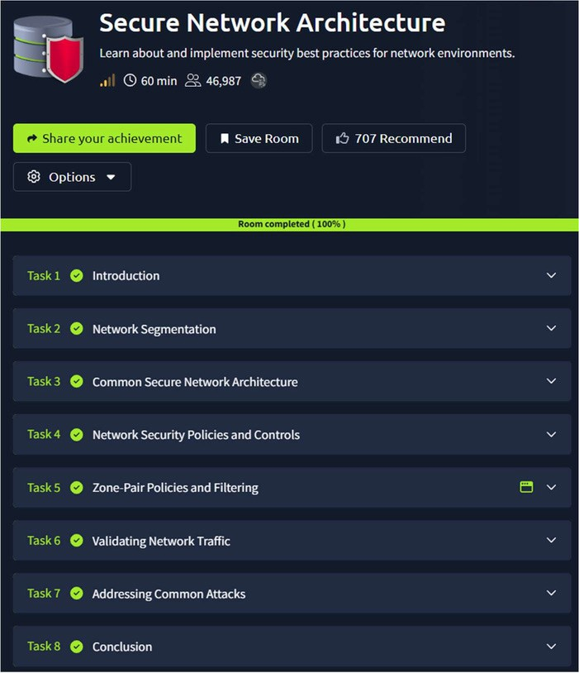

TASK 1 - Introduction
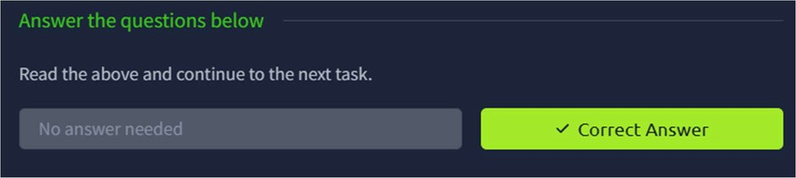
TASK 2 – Network segmentation
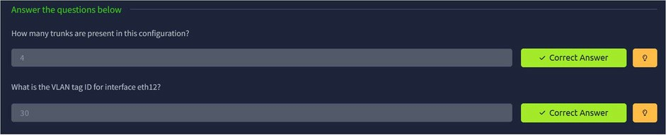
TASK 3 – Common Secure Network Architecture
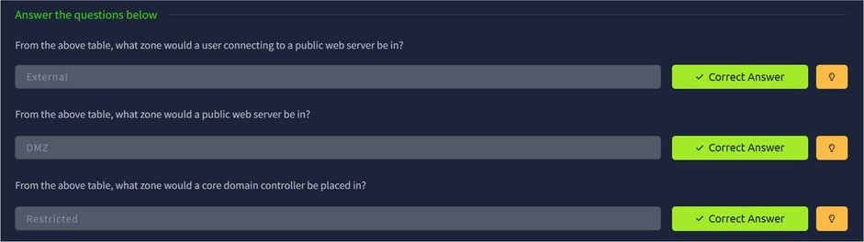
TASK 4 – Network Security Policy and Controls
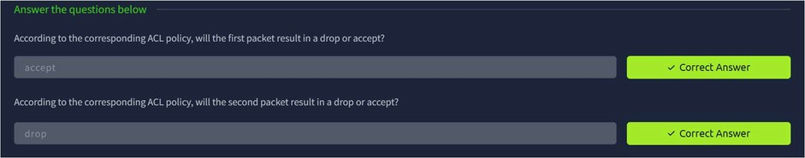
TASK 5 – Zone Pair Policies and Filtering

TASK 6 – Validating Network Traffic
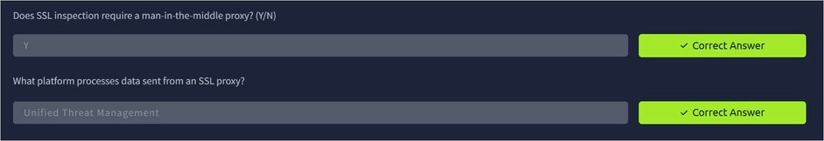
TASK 7 – Addressing Common Attacks
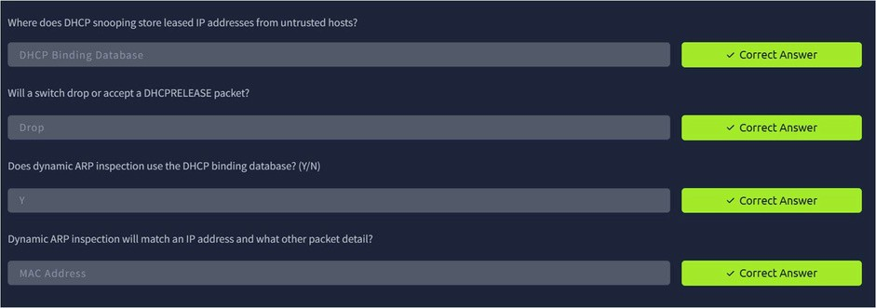
TASK 8 – Conclusion
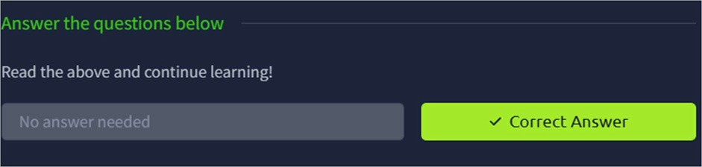
Result:
Thus the TryHackMe room Secure Network Architecture was completed successfully.

